Characteristics and mechanism of a novel chitinase mutant from
Trichoderma harzianum with enhanced activity

Xinfeng Chai ^{1#}, Jiahuang Li ^{2 #}, Jiayin Liu ^{3#}, Xiuling Chen ⁴, Wei Li ⁴, Mozhen Cheng ⁴, Yunlong Hu ¹ , Wei Zheng ¹ and Aoxue Wang ^{1,2*}

¹College of Life Sciences, Northeast Agricultural University, Harbin, Heilongjiang, 150030, China. ²College of Life Sciences, Nanjing University, Jiangsu, 210023, China. ³College of Sciences, Northeast Agricultural University, Harbin, Heilongjiang, 150030, China. ⁴College of Horticulture and Landscape Architecture, Northeast Agricultural University, Harbin, Heilongjiang, 150030, China.

Author email addresses: chaixinfeng.edu@163.com; lijh8075@sina.com; 13040216@163.com; ChenX@neau.edu.cn; 442777083@qq.com; 330627655@qq.com; 704294723@qq.com; 1115927580@qq.com; axwang@neau.edu.cn

*Correspondence: axwang@neau.edu.cn

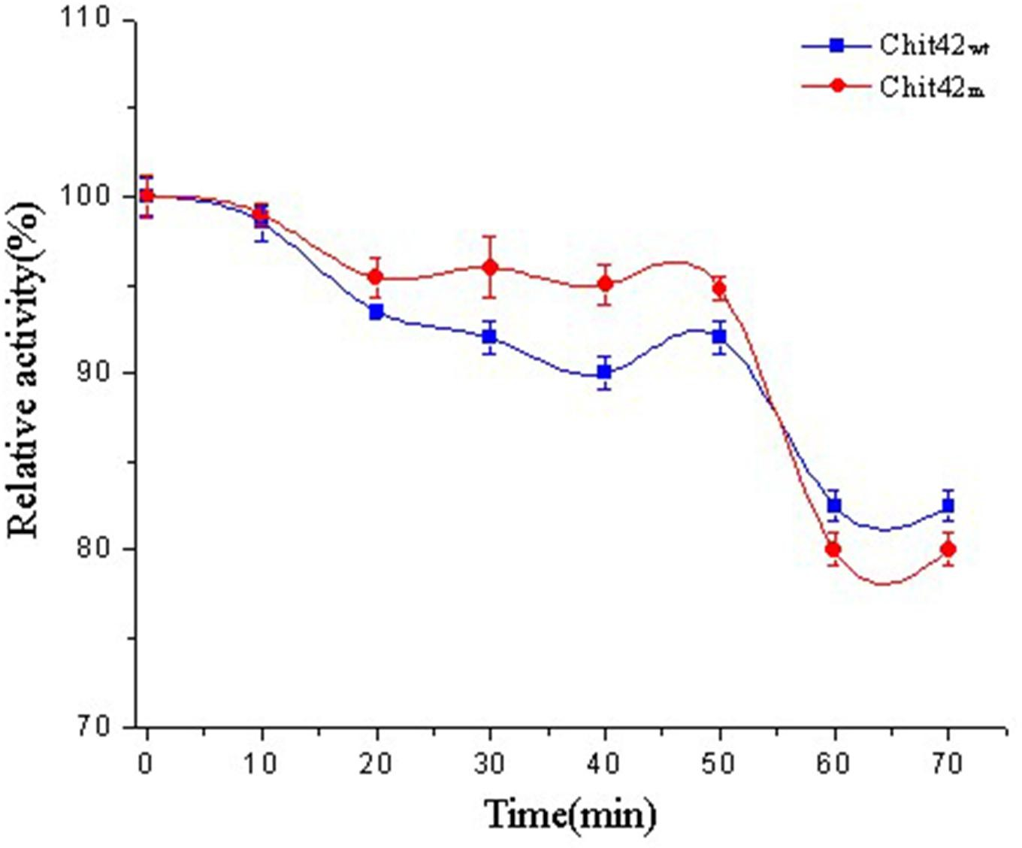

Fig. S1. Thermostability of the Chit42wt and Chit42m at 55 °C. The incubation time was in 70 min. The blue block represents the Chit42wt and the red circle represents the Chit42m. All assays were performed in triplicate and average values (Mean ± S.D.) were calculated.

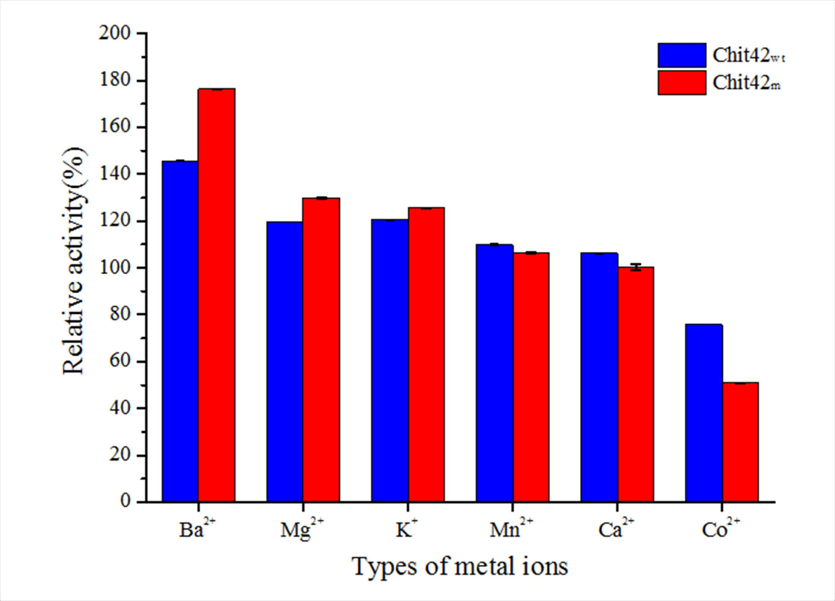

Fig. S2. Effect of metal ions on enzyme activities of the Chit42wt and Chit42m.The activity of the enzyme was determined with the addition of 2 mM ZnCl₂, CoCl₂, BaCl₂, MgCl₂, KCl, CaCl₂ and MnCl₂ solutions. The activity without any treatment was defined as 100 %. The blue block represents the Chit42wt and the red block represents the Chit42m. All assays were performed in triplicate and average values (Mean ± S.D.) were calculated.

